MUJTABA SHAHID FAIZI

BSCS-5A

#131818

LAB 4

WEB ENGINEERING

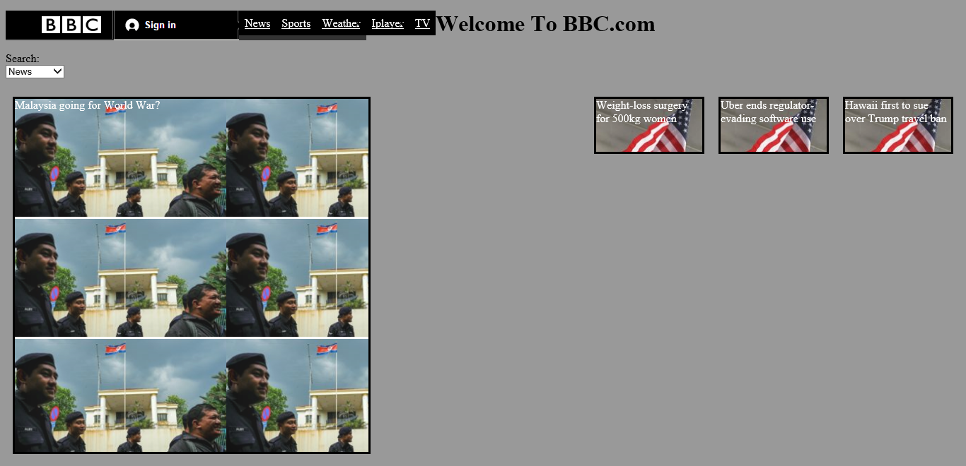

CODE:-

<!DOCTYPE html PUBLIC "-//W3C//DTD XHTML 1.0 Transitional//EN" "http://www.w3.org/TR/xhtml1/DTD/xhtml1-transitional.dtd">

<html xmlns="http://www.w3.org/1999/xhtml">

<head>

<style>

body{

background:#999

}

.box{

float:right;

width:150px;

height:75px;

margin:10px;

border:3px solid #000;

color:#FFF;

background-image:url(3.PNG)

}

.bigbox{

float:left;

width:500px;

height:500px;

margin:10px;

border:3px solid #000;

color:#FFF;

background-image:url(4.PNG)

}

ul{

list-style-type:none;

margin:0;

padding:0;

overflow:hidden;

float:left;

background:#333;

}

li{float:left;}

li a {

display:block;

color:#FFF;

text-align:center;

padding:8px;

background-color:#000;

}

li a:hover{

background-color:#111;

.heading{

float:left

font-size:12px;

color:#FFF;

text-align:justify

.abstract{background-color:#F63; color:#000; font-style:italic; font-size:10px}

.text{text-align:center; font-size:26px}

</style>

<title>lab 4</title>

</head>

<body>

<div style="float:left">

<ul>

<li><img style="float:left" src="1.PNG" >

<a href="http://www.bbc.com/"></a></li>

<li><img src="2.PNG" /></li>

<li><a class="active" href="#News">News</a></li>

<li><a href="#sports">Sports</a></li>

<li><a href="#weather">Weather</a></li> </ul>

<li><a href="#iplayer">Iplayer</a></li>

<li><a href="#TV">TV</a></li>

</div>

<div>

<h1 class="text">Welcome To BBC.com

</h1>

</div>

<div>

<p>Search:<br/>

<select name="select">

<option value="1">News</option>

<option value="2">Sports</option>

<option value="3">Weather</option>

<option value="4">Iplayer</option>

<option value="5">TV</option>

<option value="6">Radio</option>

<option value="7">CBBC</option>

<option value="8">CBeebies</option>

</select>

</div>

<div class="box" >Hawaii first to sue over Trump travel ban</div>

<div class="box" >Uber ends regulator-evading software use</div>

<div class="box" >Weight-loss surgery for 500kg women</div> <div class="bigbox"> Malaysia going for World War?</div>

</body>

</html>

DESCRIPTION: By using inline styling, I have defined a lot of divs having different formats. I have defined background, text, margin, and border properties including an input type to enter in “search”. I have also used in-line blocks to enter-in the big images with text displaying on the image.